BlazerID: SSRINIVA

Shreyas Srinivasa

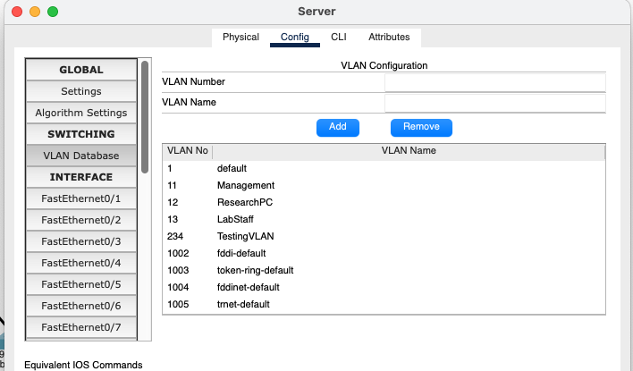

A new vlan (testVLAN) has been created on the server switch. Which will be sub advertised to the client switches, in this case the different research labs.

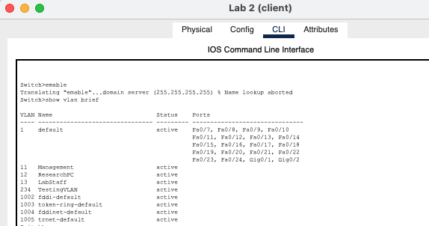

By running the -show vlan brief command on the client switch, we are able to see that the new vlan can be seen on these switches as well.

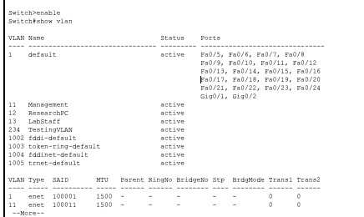

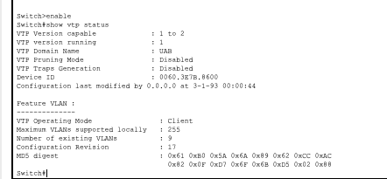

By using the command -show vtp status you can see the client side has also updated the vlans because of the increase in the “Configuration revision” number. This is possible due to the connections being in the trunk mode.

3. 